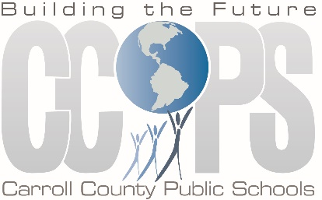
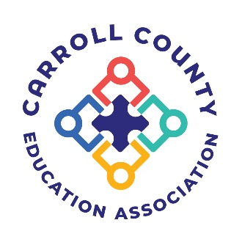
Carroll County Education Association &
Carroll County Public Schools
Present
INNOCENCE STOLEN:
PROTECTING OUR CHILDREN ONLINE
A multimedia presentation presented by
the United States Attorney’s Office
One of the most successful programs we have provided, “Innocence Stolen” is offered to school staff, parents, and community organizations to equip and empower them to address the many teachable moments that occur when accessing the internet. While the presentation speaks directly to adults, we offer the opportunity to bring children to promote conversations within families about this topic, but we do not provide guidance directly to children. We leave the decision to include children up to schools and parents.
There are several considerations prior to opening attendance to include children:
- The program does not tell children “what not to do” on the internet.
- Some children may use this program as an opportunity to learn new ways to abuse/misuse the internet.
- The program does discuss topics inappropriate for younger students including predatory behavior, sexting, and sextortion.
This program is free.
West Middle School
Date: September 20, 2022 Time: 6:00 PM
Spring Garden Elementary School
Date: October 4, 2022 Time: 6:30 PM
Linton Springs Elementary School
Date: October 11, 2022 Time: 6:30 PM

Contact the Main Office of each school for more info

